Design Thinking and Innovation: Interactive Recycling Unit Website
1. Aim:
There is a need for an interactive solution that helps individuals locate and connect with recycling units based on the type of material they want to recycle. This report presents the design and development process of an interactive website that allows users to find recycling units for different materials and facilitate collection services for bulk recyclable materials.
1.1 Background
Recycling is an essential component of sustainable waste management, yet many people struggle to find nearby recycling units that accept specific materials. The lack of accessible information prevents proper disposal and recycling of various materials, leading to increased landfill waste.

2. Design Thinking Process
The design thinking approach involves five key phases: Empathize, Define, Ideate, Prototype, and Test.
2.1 Empathize
Understanding the user's needs is crucial in designing an effective recycling platform. Key findings from user research:
- People find it difficult to locate recycling units near their homes.
- Different materials require different recycling methods, making it hard for users to know where to dispose of them properly.
- Users want a convenient system where they can schedule material pickup for bulk recyclables.
2.2 Define
User Needs:
- A website that shows nearby recycling units based on the type of material.
- Integration with Google Maps for accurate location tracking.
- An option to upload images of materials for bulk recycling pickups.
- A categorized list of recyclables, starting with textiles (old clothes to fiber recycling).
2.3 Ideate
Key Features of the Website:
- User Location Access: The website prompts users to allow location access to display nearby recycling units.
- Material Selection: Users can choose the type of material they want to recycle (e.g., textiles, plastics, paper, electronics).
- Google Maps Integration: The website fetches and displays nearby recycling centers based on the selected material.
- Upload Material Image (For Bulk Pickup): Users can upload an image of their recyclable items, and units that offer pickup services will be notified.
- Recycling Unit Details: Each recycling center's address, contact details, accepted materials, and collection services are displayed.
- Educational Section: Provides information on the recycling process for different materials.
Flow Chart:
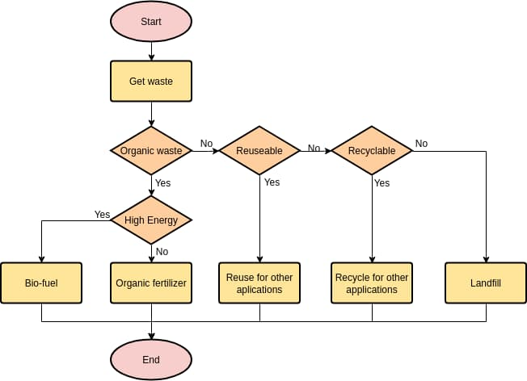

2.4 Prototype
A wireframe and basic prototype are designed before full implementation. The prototype includes:
- A homepage with an input field for selecting the material type.
- A map view showing nearby recycling units.
- A form for users to upload images of bulk recyclables.
- A contact section for users to directly communicate with recycling units.
2.5 Test
User feedback is collected from initial testers to refine usability. Adjustments include:
- Improving map accuracy for better unit location results.
- Enhancing image upload features for better recognition of bulk materials.
- Making the interface more intuitive with better navigation.
3. Website Development Process
3.1 Technology Stack
- Frontend: HTML, CSS, JavaScript, React.js
- Backend: Node.js, Express.js
- Database: MongoDB (for storing user queries, recycling unit data)
- APIs: Google Maps API (for location tracking and maps integration)
3.2 Step-by-Step Website Development
Step 1: Setting Up the Development Environment
- Install Node.js and set up an Express.js server.
- Create a React.js project for the frontend.
- Install dependencies: npm install express cors mongoose react-google-maps-api
Step 2: Creating the User Interface
- Design the homepage with a search bar for users to enter/select the material type.
- Create a map component that displays nearby recycling centers.
- Develop a form for uploading bulk recyclable images.
Step 3: Backend Development
- Set up a database schema for recycling units (name, location, accepted materials, contact info, pickup services availability).
- Implement an API to fetch and return nearby recycling units based on user location.
Step 4: Google Maps Integration
- Configure Google Maps API for fetching and displaying location-based results.
- Ensure real-time filtering of recycling units based on material selection.
Step 5: Image Upload and Recognition (For Bulk Pickup Requests)
- Implement a file upload system for users to submit images.
- Store submitted images and notify relevant recycling units for pickup.
Step 6: Testing and Deployment
- Conduct usability testing to refine the interface.
- Optimize database queries and API responses for speed.
- Deploy the website using hosting services like Vercel or AWS.
Website:

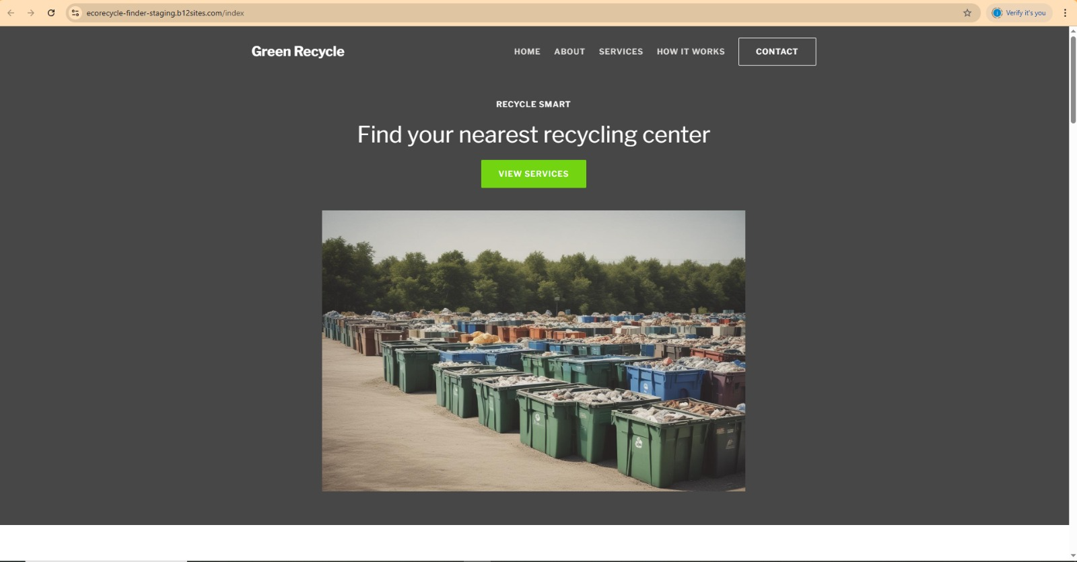
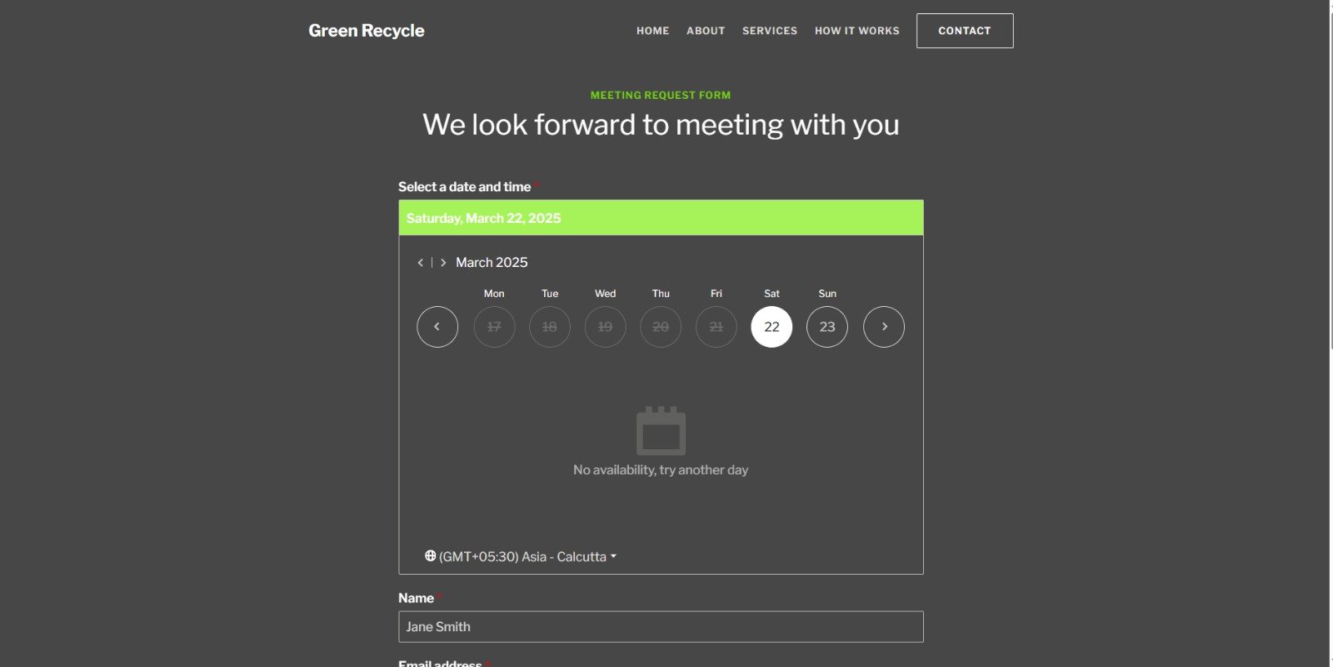

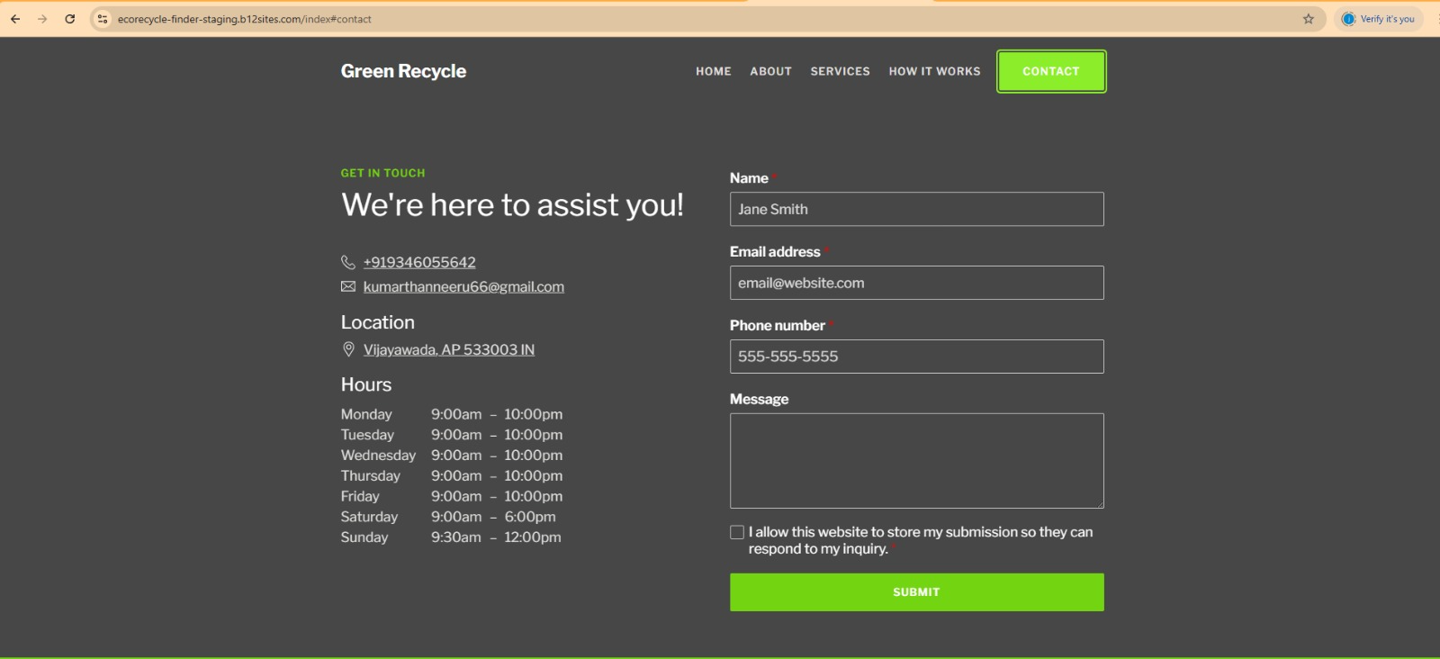

Link to the website:
Find Local Recycling Centers with Green Recycle
4. Result:
This interactive recycling website aims to bridge the gap between users and recycling units by providing a seamless way to locate facilities based on material types. By integrating Google Maps, image upload features, and real-time unit filtering, the platform enhances accessibility and convenience in sustainable waste management. Future enhancements may include AI-based image recognition for material classification and mobile application development for a wider reach.

